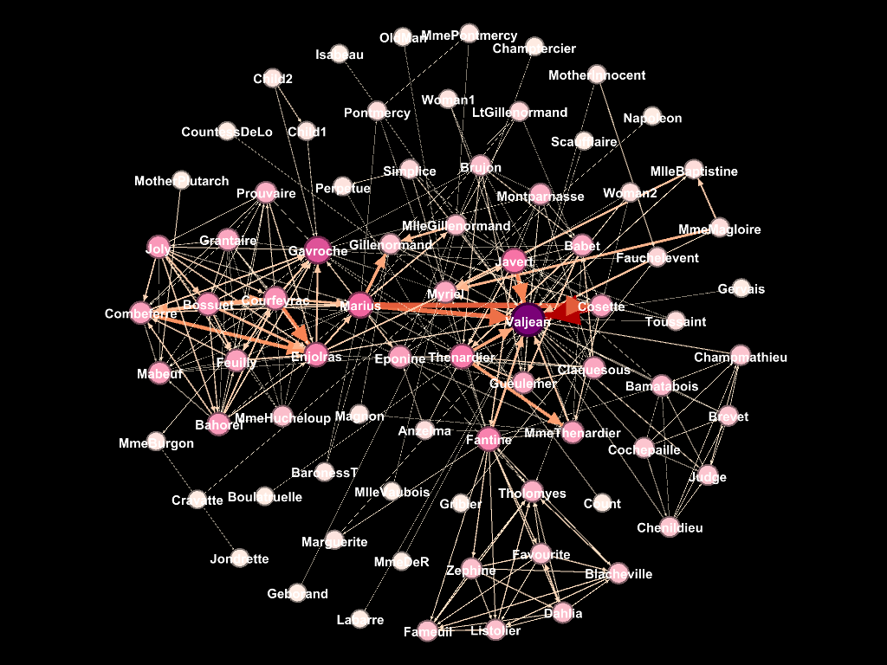

I selected the „Les Miserables“ dataset, on which I applied the Fruchterman Reingold layout. I personally found it the clearest. It seems to give the most space to the individual nodes. I also found the circle shape of the layout quite well arranged, even though I was wondering, whether the position on the outskirts of the circle actually corresponds to the lower importance of the nodes positioned there. In most cases, yes. But when it does not, I think it creates a certain confusion.

The average degree is 3,299. In the dataset, we can find one visible center – Valjean – and multiple smaller centers with a rather high degree of centrality. On the other hand, quite a lot of nodes are only connected to one another node, lowering the average degree of centrality. That also corresponds to the rather low density of the graph (0,087), showing there is only ca. 3 on every 40 possible connections.

The dominant center of the graph of degree centrality is Valjean, followed by Thenardier, Gavroche, Marius, and Javert. Those are also the strongest actors of Betweenness centrality. Even closeness would show Valjean as the strongest member, even though since he has many connections to relatively peripheral nodes, it would have raised their position and lowered the ones of for example Favourite or Fauilly. In the Eigenvector, many characters shown in darker pink would be of a much more crucial role.

I would say in this case, centrality is definitely the most fitting measure of power and influence in the network and clearly shows the main character of the novel.